PLATE 10B: Parksville, Tennessee, 1911 & 1912

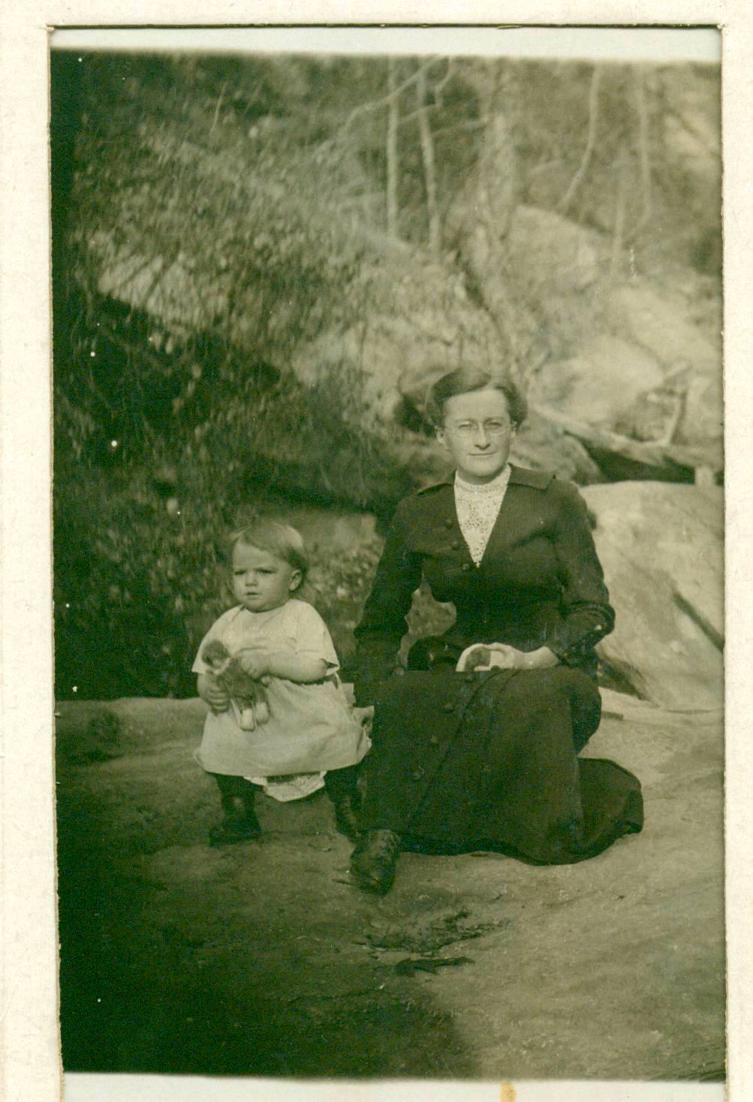

Jane Glendenning and Grace

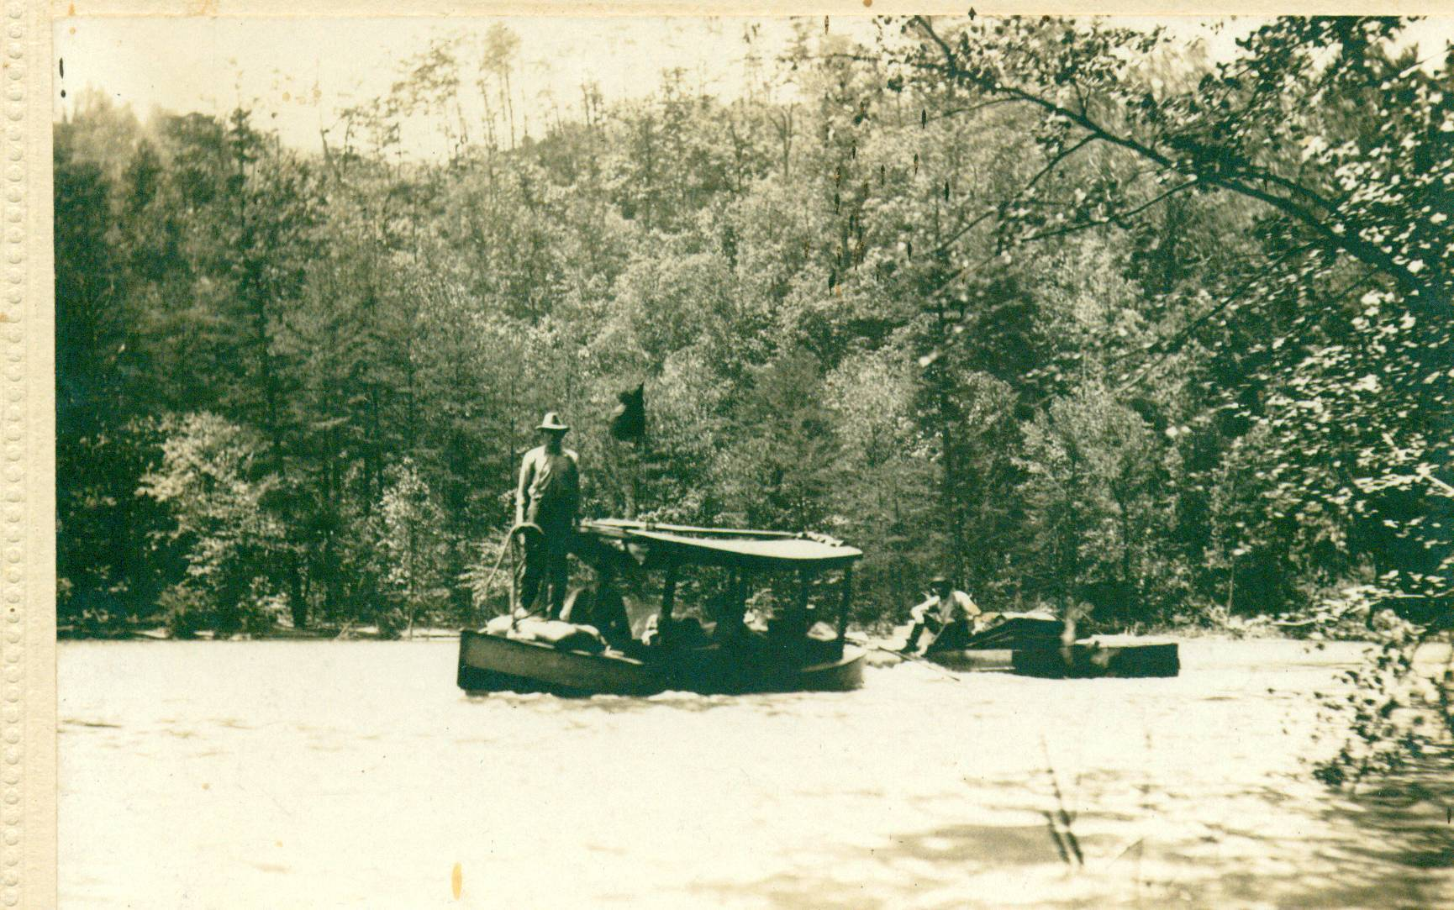
Ocoee Lake above dam

